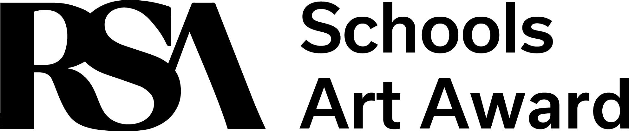
Royal Scottish Academy
The Mound
Edinburgh
EH2 2EL
0131 624 6119
friends@royalscottishacademy.org
The RSA is a Scottish Charity No:SC004198

Thank you for your interest in participating in the 2024 edition of the RSA Schools Art Award. Please complete and return this form to friends@royalscottishacademy.org to receive further updates about the awards. If you do not register in advance, please include this form with your submission.

School Name:
Teacher/Main Contact:
Email of main contact:
School Address:

For consideration for the Brodies Regional Award, please include which region your school is located within (North, East, South/West):
Has your school submitted within the past 5 years:

